CLOUD  Collaborate and communicate like a modern business should.  Take advantage of the flexibility and scalability of the cloud.  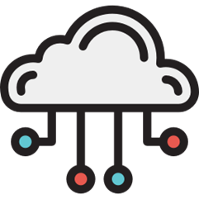  - data center and colocation services  - disaster recovery as a service  - infrastructure as a service  - public/hybrid/private cloud services  - virtualization | 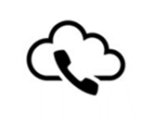  VOICE  - UCaaS / hosted voice  - Cloud contact center  - SIP  - Audio/video/web conferencing solutions
CONNITIVITEY  Get the speed, stability, and reliability you need – at every location.  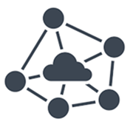  - MPLS  - fiber  - Ethernet  - DIA  - fixed wireless  - managed broadband | MANGAGED SERVICES  Outsource your IT headaches to us so you can get back to business.  - IT Help Desk    - cloud-based expense and inventory management  - technical project management
CYBER SECURITY AND COMPLIANCE  Stay ahead of the hackers with proactive and reactive cyber security.  - unified threat management  - managed firewall (cloud and CPE)    Note: SD-WAN is optional. The honest truth is it’s for very large corporations. | SD-WAN  Optimize your network for the security and agility you need to grow.  - MPLS replacement and/or enhancement  - high availability internet  - QoS-enabled internet  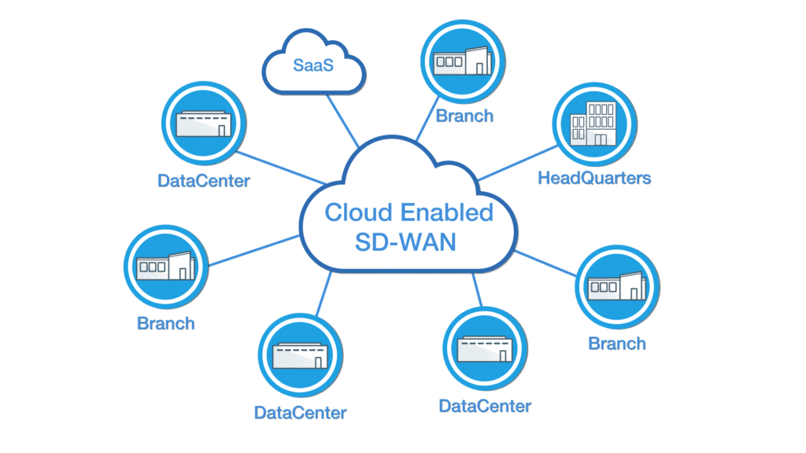  - same IP seamless failover — all managed or unmanaged.

